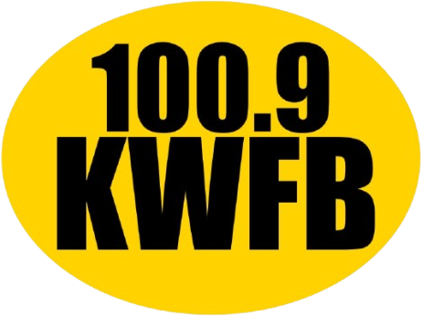
DIGITAL
ADVERTISING
ONLINE AT
1009KWFB.COM
Available Website Zone | Banner Size | Exclusive Monthly | Rotation Monthly
Header Leaderboard | IAB Leaderboard (728x90) | $75 | $50
Homepage Leaderboard 1 | Custom (545x90) | $75 | $50
Right Ad 1 | IAB Medium Rectangle (300x250) | $100 | $75
Right Ad 2 | IAB Medium Rectangle (300x250) | $100 | $75
Left Ad 1 | Custom (250x180) | $100 | $75
Left Ad 1 | Custom (250x180) | $100 | $75
Footer Leaderboard | IAB Leaderboard (728x90) | $100 | $50
Footer Ad 1 | IAB Rectangle (180x150) | $50 | $25
Footer Ad 2 | IAB Rectangle (180x150) | $50 | $25
Footer Ad 3 | IAB Rectangle (180x150) | $50 | $25
Footer Ad 4 | IAB Rectangle (180x150) | $50 | $25
Footer Ad 5 | IAB Rectangle (180x150) | $50 | $25
Mobile Ad Unit | Custom (320x50) | $75 | $50

4245 Kemp Suite #302, Wichita Falls, Texas, 76308
Phone: (940) 322-1009
1009KWFB.COM

